**BST assignments**

Mandatory

1. Refer the example code of BST using array in socodery. Add the traversal methods below.

a. int inorder_traversal(char *array[], int count)

b. int preorder_traversal(char *array[], int count)

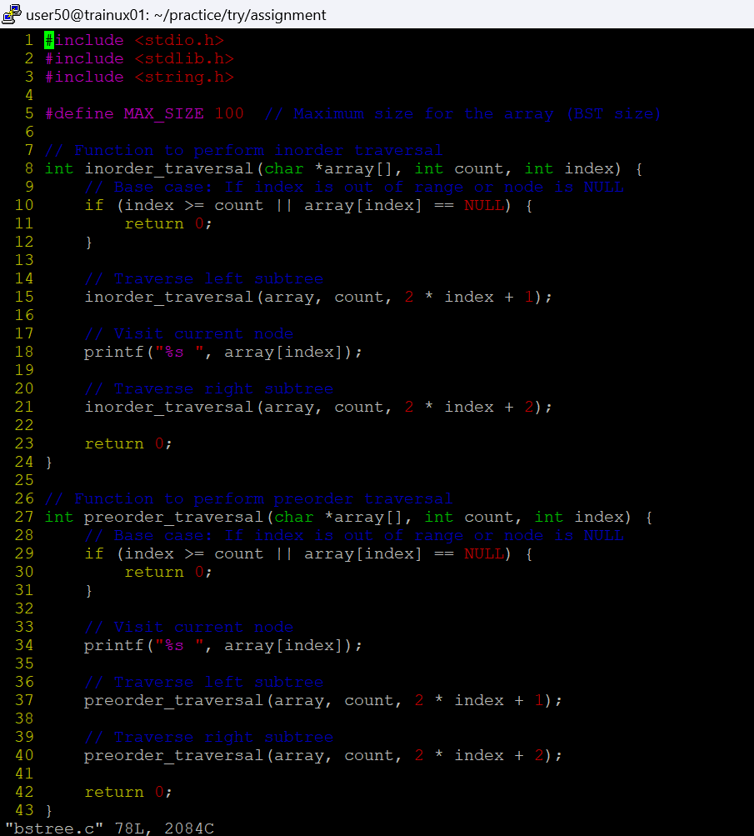

2. In main(), instead of line below, update and modify to read MAX dimension at runtime.

char *array[MAX];

char **array; //read MAX dimension from the user at runtime and use it

Update the remaining functions accordingly and test it.



